# Project Selection

### Introduction

The members of our team individually brainstormed ideas that the whole team could potentially work on during the quarter. After researching different robots and ideas, each project idea was given a paragraph description under “Project Ideas”. Then, an overall group rating for each project was made in a “Decision Matrix”, allowing the group to narrow down the choices from five to three. These final three selections will be among those considered for the final project, which was selected in the very final section.

### Project Ideas

* 1. **Gardening Robot**: This project would involve a robot that is able of managing the gardening of a plant. The steps in the planting process which the robot will be capable of are driving in soil, digging up soil, dropping a seed, watering the seed, and fertilizing the seed. This robot has real-world applications that involve simplifying the gardening and farming process that could be used on a personal or industrial level. The parts required for the robot would involve containers and release systems for the seeds, water, and fertilizer that would involve valves and switches. The digging process would involve a motor attached to a drill-like object. FarmBot Genesis is a similar robot on the market that can plant a seed with a seed injector and water it precisely, build regimens for taking care of a plant by using its sensors to detect outside conditions, detect weeds and destroy them too ("Introducing FarmBot Genesis", 2016).
  2. **Object rejection and counting machine (ORCM)** : This project would be a robot whose purpose is to reject items that do not fulfill a specific condition, related to size and weight. This would be similar to the “conveyor belt sorting bot” created by Gurmeet Sharma that is able to sort objects based off height ("conveyor belt based sorting machine object size detection eeast chandigarh", 2009). In this example, the object rejection and counting machine has a conveyor belt and a sensor that identifies the size of the object, if the object doesn’t fulfill the condition, it is pushed out of the conveyor belt. It is very useful for quality control and inventory in factories as it can sort out anything that does not satisfy a condition. For example, it can determine whether a tennis ball fulfills a certain criteria for size and weight for them to correctly perform. It can also be applied to determine the type of coin based on the weight and size. This project will likely require to buy parts because it has a conveyor belt system, that uses two or more pulleys; and a load sensor to determine the weight. From the provided parts this project will require a DC motor.
  3. **Companion Bot**: This project would involve an autonomous robot that follows a device through Bluetooth or wireless communication. The robot would be similar to companion bots like Kuri, meant to follow a person around while providing auxiliary services ("Introducing Kuri, The Home Robot | Mach | NBC News", 2017). Kuri is a companion bot that fulfills a wide range of functions that include recognition of faces, playing music or working as an alarm. The robot can respond to the touch and can moves around through any surface thanks to a set of sturdy wheels. Rather than providing all the same functionality as Kuri, the robot would only follow a person around and hold materials that person finds useful (water bottle, phone, speaker, etc). These personal items will be able to add supportive services to the robot, such as playing music. This project would be useful as a prototype to see how people will want to interact with an autonomous companion bot. The project will focus on avoiding obstacles using distance sensors, following an object through bluetooth communication, and 3-D printing a customized robot frame to fit the personal items. This project will require a bluetooth-capable device to communicate with the robot, but a phone with such capabilities is owned by all members of the group.
  4. **Stair Climbing Vehicle**: Semi tracked vehicle with ability to climb stairs. Basic design would consist of four independently driven tracked wheels, and an adjustable wheelbase. Would need to have ability for object and environment detection and obstacle avoidance. Required parts would be infrared or some sort of LIDAR for object detection, on-board cameras for driver visuals, multiple motors and servos for movement. An example of the final robot would be like the robot designed by Transcend, which is built to assist police by climbing up stairs using a tread drive base ("Transcend Tactical - Introducing the first hassel-free Tactical Robot", 2018). Thought the example is much more complex than what is being planned, the robot can can ascend 3 steps at a time in up and down articulated movements that produce a downward compression force.
  5. **Kitchen Aid Robot**: This project would be an autonomous robot that could crack an egg by following set movements, or a robot that could make a cookie dough given the specific amount of each ingredients. This robot will only focus on one single task following a pre-programmed set of movements similar to Molly’s Kitchen Robot prototype ("Robot Kitchen - Behold The Future", 2016). This bot will be able to use a motor to spin, raise, and lower the arm, and use precise movements to ensure nothing gets broken in the process.The robotic kitchen has a pair of fully articulated hands that reproduce human movements when cooking, and is operated through a touch screen. This project will save people time and effort in cooking. To prevent it from crashing due to water, we would add water-proof layer to it.

### Decision Matrix

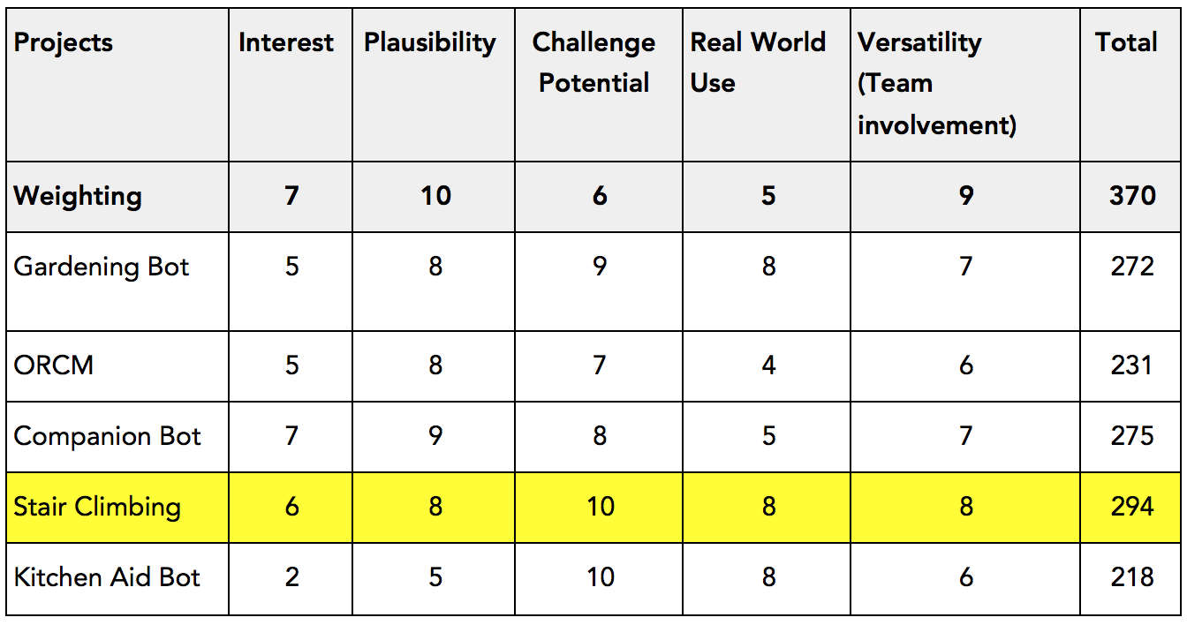

*Table 1 - Decision Matrix*

In our Decision Matrix (Table 1), interest (Col. 2) was our third most important category in order to keep us motivated throughout the quarter in order to want to spend time on this project. Plausibility (Col. 3) was the most important category to our group since we all wanted a finished product at the end of the quarter with the parts provided. Similarly, versatility (Col. 6) was our second most important category since we wanted to keep all interested team members involved in a project they could finish. Challenge potential (Col. 4) was also considered so that if a particular part of the project was done quickly, there was the ability to increase the scope of the project. Also, challenge helps us think out of the box to help us solve problems that may come up. Finally, real-world usage (Col. 5) was considered since our project is a prototype to solve a real-world issue.

**1st Choice**: *Stair Climbing*

* + The team thinks this project would provide a challenge in design and execution, and is thus our top choice. We also believe that the driving mechanics associated with independently powered wheels would be sufficient work for the mechanical, electronic, and programming sub-teams. There is potential in this project to be able to handle different stair sizes ranging from smaller than the robot’s wheels to human-designed stairs, meaning we can adapt this project to our engineering ability.

**2nd Choice**: *Companion Bot*

* + This project allows for a creative component and allowance for differing levels of complexity. The idea of making a robot for personal use is one that appealed to many members of the group, as it would serve our own purposes after it is complete. Also, the challenge of getting a robot to drive and follow a device should give the programming and electronics sub-team plenty to work on.

**3rd Choice**: *Gardening Robot*

* + This project is the most multifaceted of the three final projects since it will do more than just drive. The different subsystems required to fully garden a plant provide plenty of opportunities to design creatively and allow the project to adapt to our own skill sets. The practicality of the bot combined with the team involvement and ability to finish it make this one of our top three choices.

### Final Selection

As our final decision, we decided to work on the stair climbing robot due to its challenge potential for both the mechanical and electrical sub-teams. There are many possibilities in the design of the robot as well, which gives our team opportunity to brainstorm.